**Unit 2 AP Computer Science A Practice Exam**

**Objects, Classes, and the String and Math Classes**

Section I – Multiple Choice

Optional Time – 25 minutes

20 Questions

1. Java is known as a(n) ______-oriented programming language.
2. class
3. object
4. field
5. code
6. Complete the analogy:

Blueprints are to houses as _______ are to ______.

1. classes, fields
2. objects, classes
3. objects, methods
4. classes, objects
5. In Java, objects:
6. Do the actual “work”.
7. Are derived (created from) classes.
8. Are limited to only 100 per program.
9. I only
10. II only
11. I and II
12. II and III
13. I, II, and III
14. What part of a Java class defines the behavior of a class (what it can do)?
15. Fields
16. Constructors
17. Methods
18. Main methods
19. Which of the following are true about constructors of a Java class?
20. Constructors “construct” classes.
21. Constructors initialize the fields of a newly created object.
22. Constructors have the same name of the class they are in.
23. I only
24. II only
25. I and II
26. II and III
27. I, II, and III
28. Class names usually begin with a(n)?
29. Lowercase letter
30. Capital letter
31. Number
32. Underscore
33. Classes ______________ in Java.
34. define a type.
35. do the actual work.
36. convert Java code into binary for the computer to understand.
37. define what a field knows and what that field can do.
38. When a method does not return anything, it is considered _____.
39. static
40. void
41. the main method
42. Main methods
43. APIs stand for?
44. Application Profile Instantiation
45. Application Program Interface
46. Applicable Program Interface
47. None of the above
48. Which of the following are true about String objects?
49. String objects are immutable, meaning that their methods do not modify the object itself.
50. String objects can be concatenated together using the + operator.
51. Primitive values, such as integers and doubles, can be concatenated to string objects, and in doing so, are also converting to into the string type.
52. I only
53. II only
54. I and II
55. II and III
56. I, II, and III
57. Which of the following associations between escape characters and their purpose are false?
58. \” – Allows for double quotes inside of string literals.
59. \\ – Allows for new lines inside of string literals.
60. \n – Allows for tabs inside of string literals.
61. I only
62. II only
63. I and II
64. II and III
65. I, II, and III
66. Given any string, at which index is the string’s first character located?
67. 0
68. 1
69. Length of the string
70. Length of the string – 1
71. What is the output of the code below?

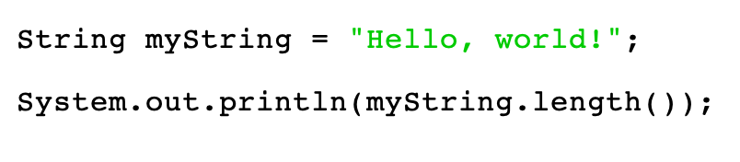

1. 10
2. 12
3. 13
4. 15
5. What is the output of the code below?

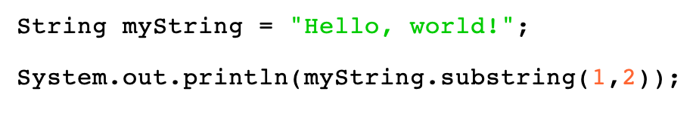

1. H
2. e
3. He
4. el
5. What is the output of the code below?

1. 11
2. 12
3. 13
4. 14
5. What is the output of the code below?

1. true
2. false
3. 1
4. 2
5. What is the output of the code below?

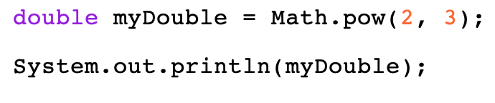

1. 8
2. 8.0
3. 9
4. 9.0
5. Which of the following outputs is not possible from the code below?

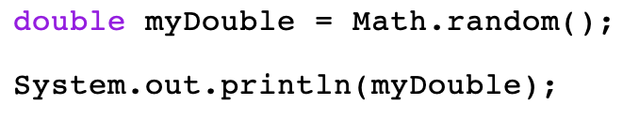

1. 0.6620460321590499
2. 0.007017489720703707
3. 0.0
4. 1.0
5. Which package are both the Math and String class part of?
6. java.classes
7. java.util
8. java.lang
9. java.pkgs
10. Which of the following are true about static methods?
11. Static methods are used on objects not initialized.
12. All of the methods from the String class are static methods.
13. Only the .random( ) and .pow( ) methods from the Math class are static, and the rest are not.
14. I only
15. II only
16. I and II
17. II and III
18. I, II, and III

**END OF SECTION I**

Section II – Free Response Section

Optional Time – 25 minutes

1 Question

1. In the space below, design a class from scratch named Car that contains the following fields:
2. The class must contain the following fields:

|  |  |
| --- | --- |
| **Field Name** | **Field Description** |
| make | Describes the brand name of the car. |
| Model | Describes the model name of the car. |
| isConvertible | Describes whether or not the car is a convertible. |
| numPassengers | Describes the number of passengers in the car. |

1. Design and implement a constructor for your new Car class that takes in values for all four fields and initializes them.
2. Design and implement the following fields to your Car class:

|  |  |
| --- | --- |
| **Method Name** | **Field Description** |
| addNumPassengers  (int newPassengersToAdd) | The method adds the number of passengers passed into the parameter to the numPassengers field. |
| printMakeModel  () | The method prints the make and then the model of the car, with a space separating them. |

1. You must use the appropriate keywords and fully complete the class to receive full credit.

Complete the Car class below.

/** Defines the Car type. */

public class Car

**END OF SECTION II**